After adding the active directory/domain service role (on DC VM) and failover cluster feature (on HA nodes), **restart** them.

At this point the DC VM is also promoted to domain controller and a domain name is created. Check previous notes.

**Adding VMs to domain**

**Step 1: turn off firewall and internet**

Click each and TURN OFF them

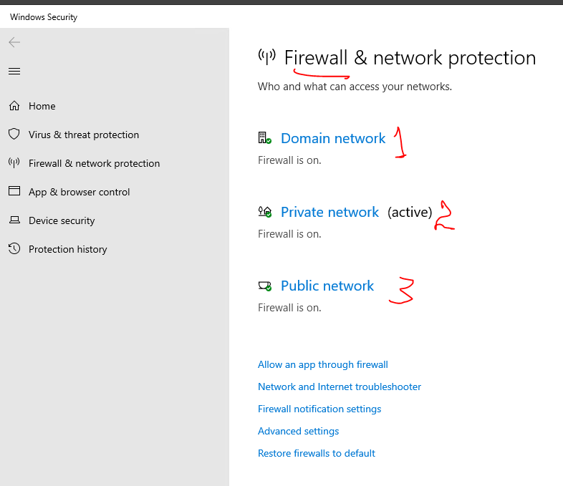 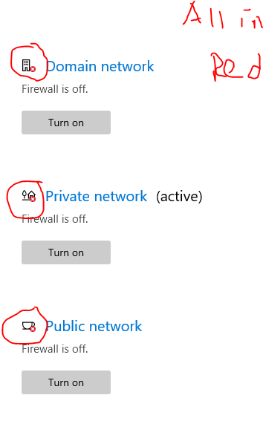

**Step 2: click WORK GROUP and add VM to domain**

Use the DC VM credential

Click change

Type domain name and add. Use DC VM’s credential.

**Step 3: Restart VMs**

**Step 4:**

**Add the account you login to the VMs into domain user and give higher privilege if it has no privilege access. This must be done on the domain controller VM.**

